**ECE 414 – Embedded Systems**

**Implementation Plan for Lab 03 – Software State Machines and Timers**

GuoYuan Li (Scribe)

Harry Zhu

Sep 1, 2020

**1. Introduction**

The objective of this lab is to learn to write basic synchronous state machines in C programs to capture time-ordered behaviors in an embedded system as well as to understand the use of timers in PIC32. In addition, it is intended to learn how to debounce a press button in software and design both software and hardware implementation of a board game on MCU PIC32, which will be described detailedly in the next section.

**2. Requirements**

The goal of this lab is to design a simple 1 dimension Pong game, where an lightened LED represents the “ball”, and was designed using multiple synchronous state machines, including the button debouncers and ball(LED) position tracker. Specifically, it has the following requirements:

1. The ball is randomly assigned to one of the players and the LED closest to that player is lighted indicating he/she should serve.
2. When that player presses the button, the game begins and the ball travels from one LED to the next toward the other player.
3. When the ball reaches the LED adjacent to the other player's button, that player must “hit" the ball by pressing the button, which causes the ball to travel in the opposite direction.
4. The ball travels back and forth in this way until one of the players “misses" by not pressing the button when it is at the end or by pressing the button when it is not over the end.
5. When a player misses, the LED nearest the winning player flashes a few times (at least 3). Then go back to step (a) and repeat.
6. The speed of the game shall vary, starting with a delay of approximately 300ms between ball movements and gradually increasing at the end of each turn up to a "Ball" Left "Paddle" Button LEDs Right "Paddle" Button 2 delay of approximately 100ms.
7. The delay shall return to 300ms when the system is reset.
8. Pushbutton inputs shall be debounced in software

**3. Architectural Description**

This section describes the planned architecture for a design, generally partitioned into a hardware architecture and a software architecture.

**a. Hardware architecture**：

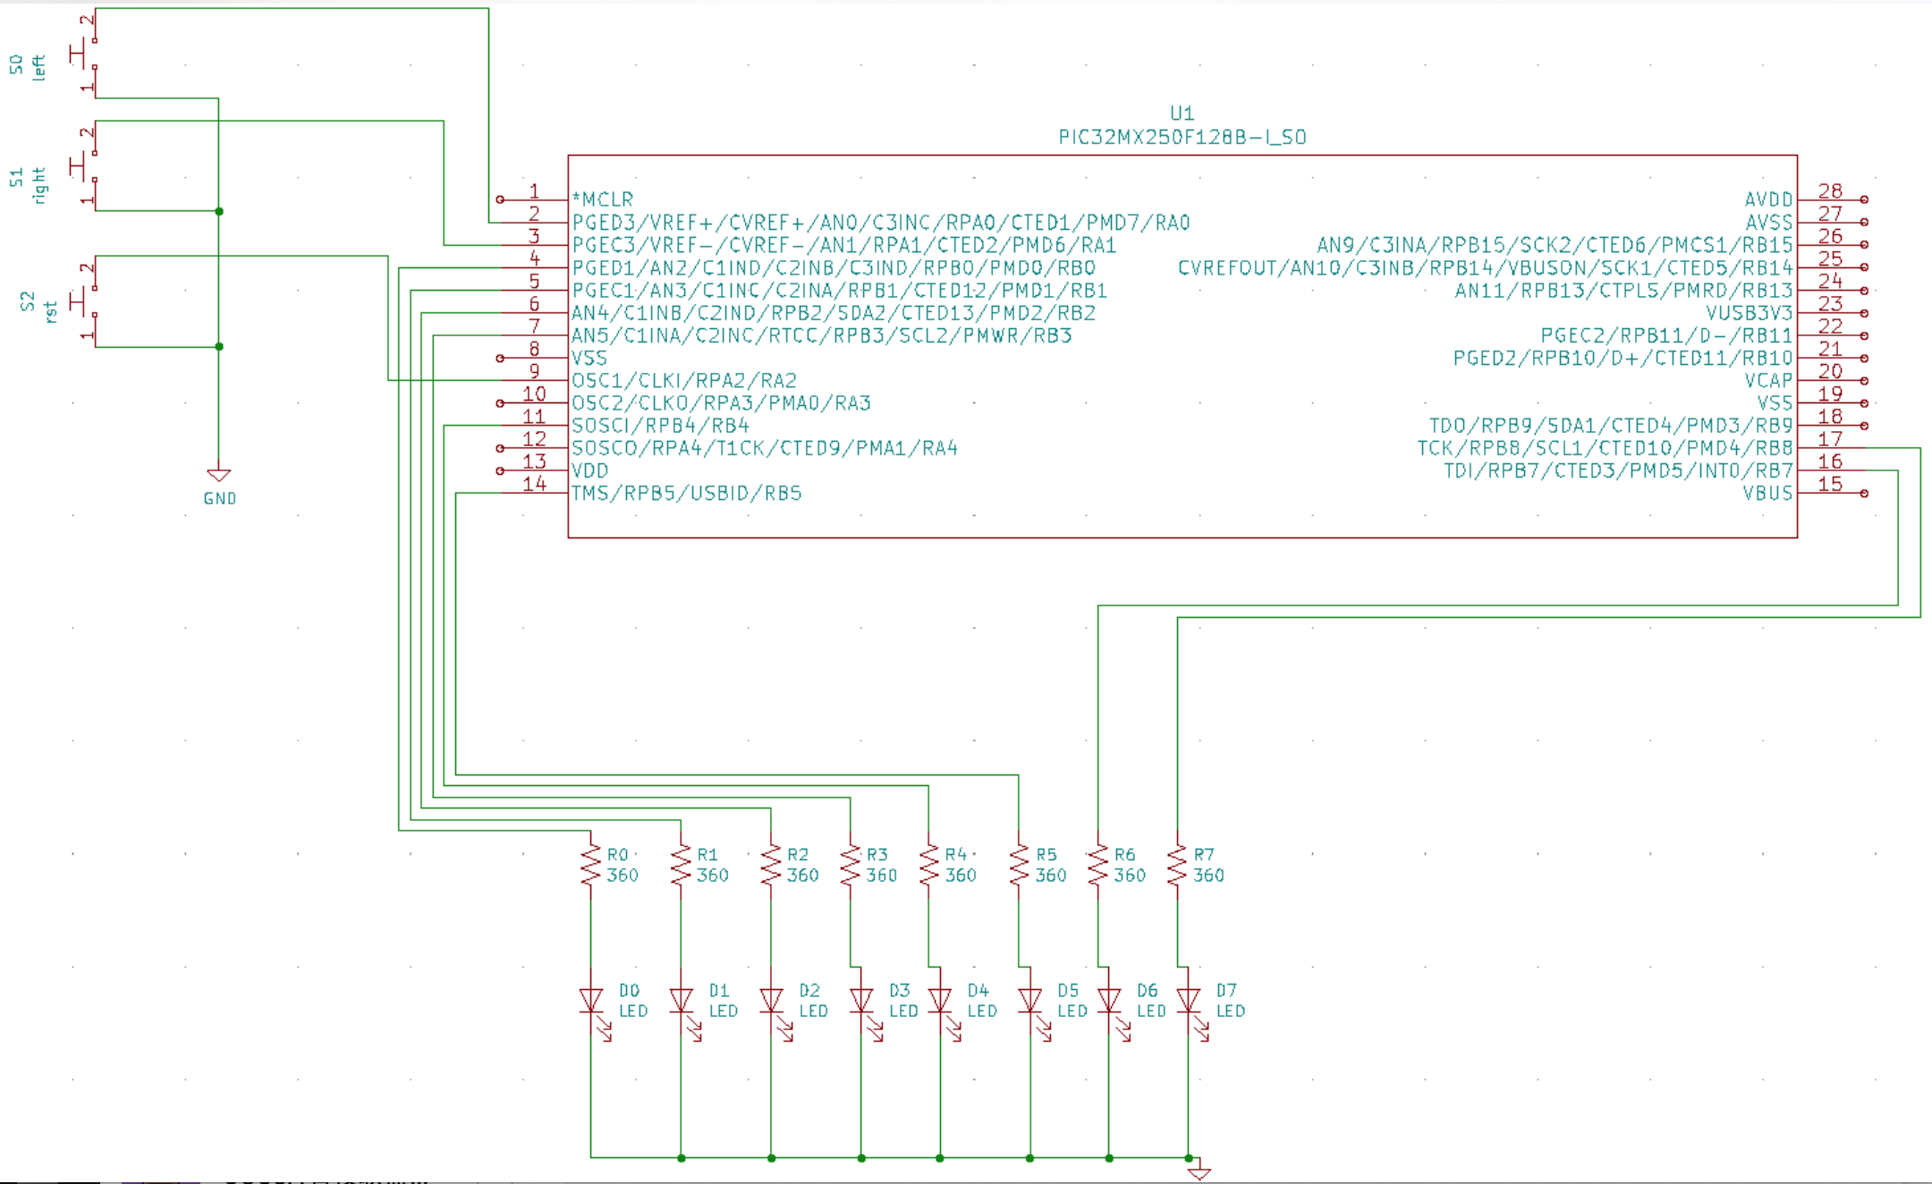

Figure 1. Preliminary Hardware Schematic Diagram

**Hardware Description:** In order to simulate a game similar to a one-dimensional version of “air hockey” which is essentially a ball bouncing between two ends, the hardware implementation can be broken into three fundamental parts. First part of the hardware implementation is the PIC32 microprocessor, used to store the program and having the I/O connected to it. Eleven of the microprocessor pins are used in the implementation, among which three are input ports and eight are output ports. Second part is the LEDs, which can be generally considered as the output of our system. Eight LEDs are used in the game, in which they form a line as the path for the ball to move on. In the game players have to be on either side of the LED line preventing the ball to hit the end of the line without bouncing back. An eight-bit output signal is connected to the eight LEDs, as each bit represent one of the LEDs. Each LED is connected to a resistor which connects to one of the RB pins of the microprocessor. The third part is the input devices. Three buttons are used in the game as input devices, two of which represent either side of player input, and third button as the reset button for the game to restart. The three input buttons are connected to three RA ports configured as input pins of the microprocessor.

**b. Software architecture**

**Global Variables**:

The program will have 3 8-bit global variables.

-**count:** This variable is initialized to 0 and increments by 1 in the while(1) loop.

**-dir**: Calculated from masking “count” by 0x01. This variable “dir” decides who serves the ball. Since “count” is always counting and the least significant bit is either 0 or 1 with 50/50 chances, it is reasonable to assume that the 2 players have equal chances to serve the ball.

-**period:** the shared time period for Ball_Tracker module and the button_debouncers.

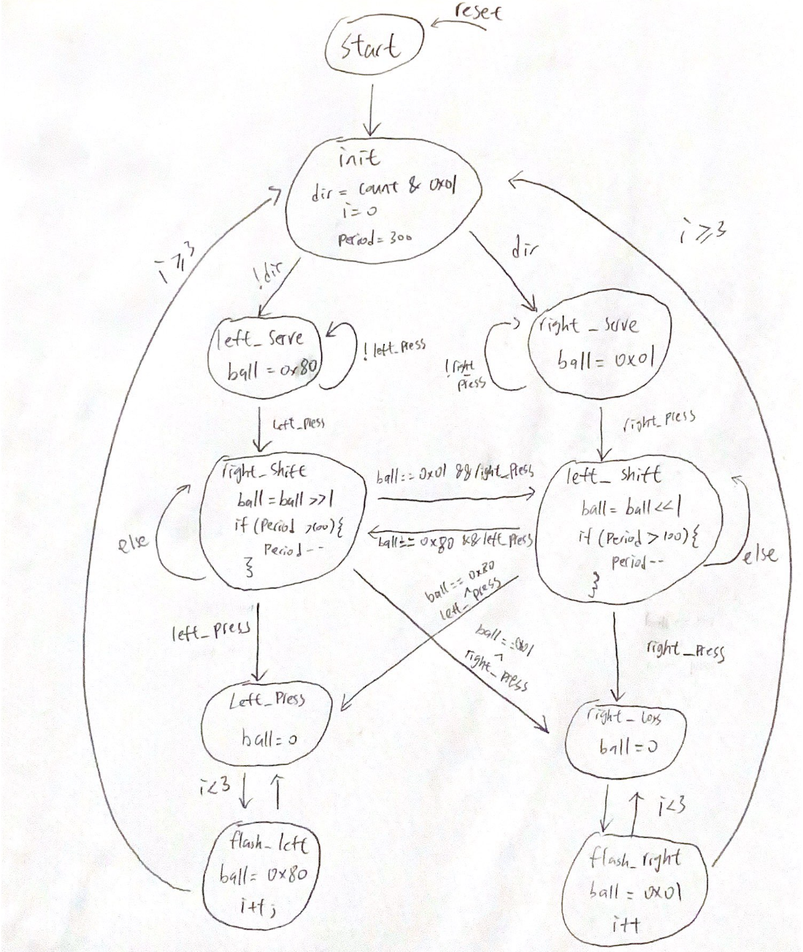

Figure 2. Ball_Tracker state machine state diagram

**Ball_Tracker Description:** This Ball_Tracker FSM is the main module tracking the ball’s position. It has a local 8-bit variable called “ball,” the output. In addition, the FSM receives left press and right press as inputs from the button_debouncer module, which is included next. There is a init state where the FSM is initialized to. The FSM randomly assigns a player to serve according to “dir.” If “dir” is 0, the FSM enters left_serve state, meaning left player serves. If “dir” is 1, the FSM enters the right_serve state, meaning the right player serves. The FSM waits for the right or left button to be pressed in the corresponding serve state. The ball will be assigned to the endpoint accordingly. If the signal left press or right press is high, the FSM will shift to corresponding shift state, either left shift or right shift. In the shift states, the LED is shifting in the corresponding direction and the time period is decreasing by 1, if greater than 100, each time to make the shifting faster. If the ball is shifting and the opposite player presses the button, the opponent loses, the FSM enters corresponding loss state. If the ball reaches the end point and the player fails to press the button, he or she loses and FSM enters the corresponding loss state. If the player presses the button on time when the ball is at the end point, the FSM goes to the state with opposite shift direction. If one player loses, the LED closest will flash 3 times and return to init state, where the process repeats.

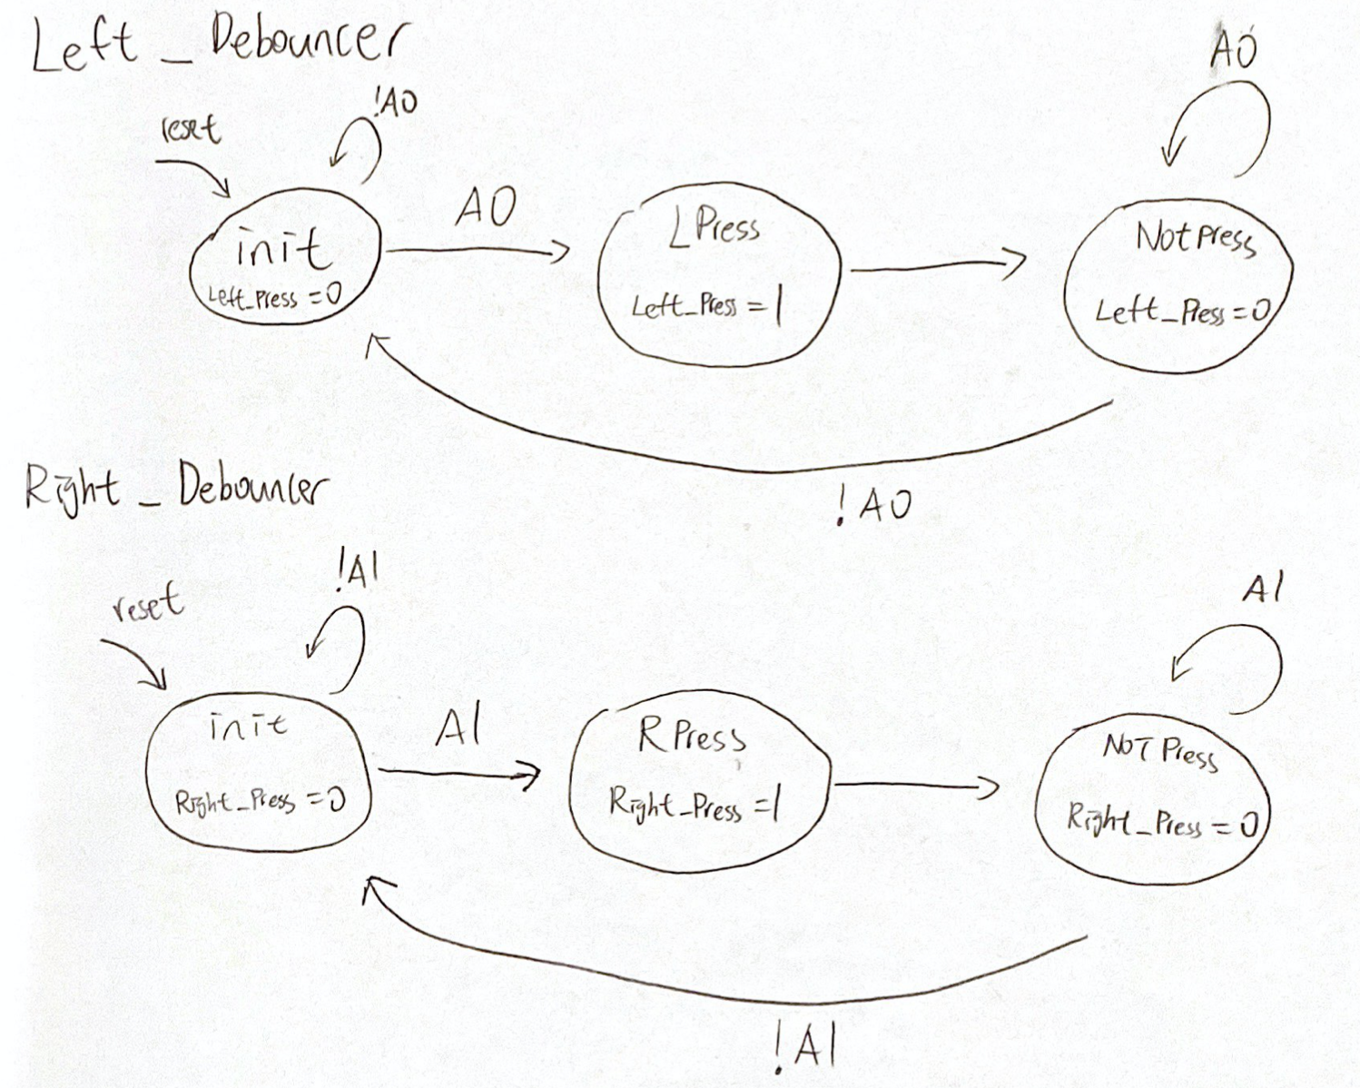

Figure 3. Left and Right Debouncer state diagram

**Button_Debouncer Description:** This button_debouncer FSM includes both Left_Debouncer and Right_Debouncer that helps to filter the signal fluctuations and generate a single pulse. The left and right button debouncers behave the same except setting different “press” signals to high. They all begin with an init state, waiting for either A1 and A0 to be asserted high(can be done by using in & 0x01). If A1 or A0 is asserted, the FSM enters either LPress or RPress state that asserts the press signal accordingly. Then, the FSM automatically enters the NOTPress state where it waits for A1 or A0 to fall. It will then go back to the init state when the signal drops.

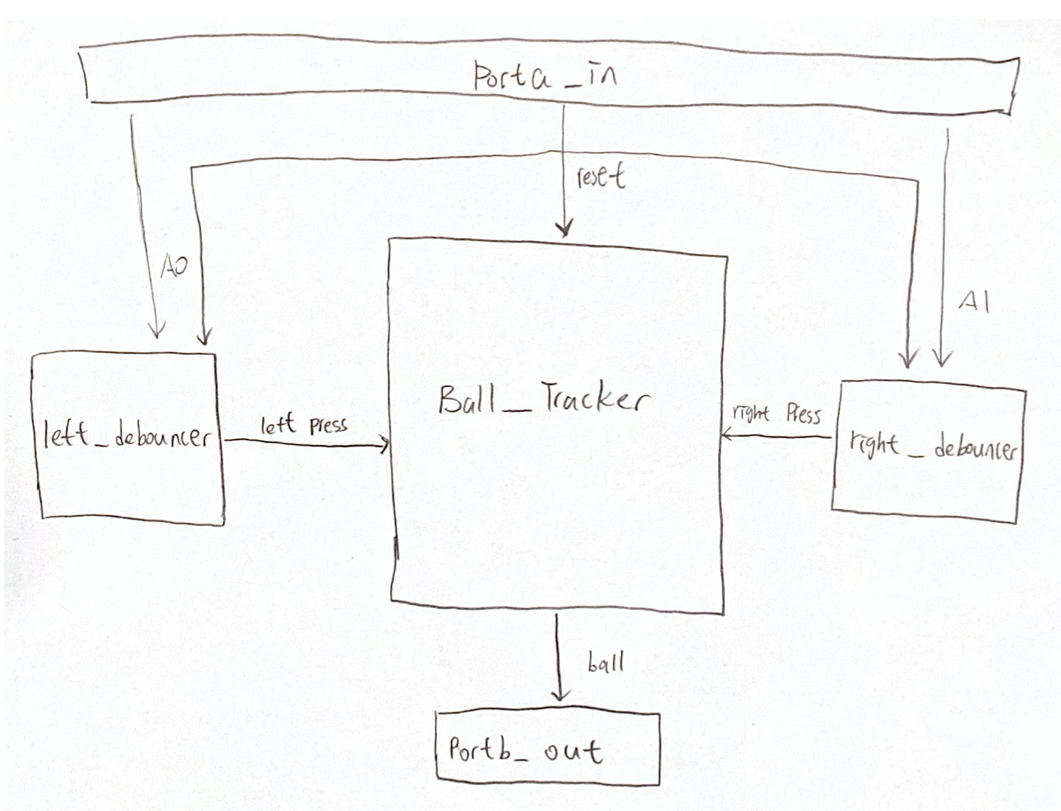 Figure 4. High Level Block Diagram

**High Level Block Diagram Description:** There are 5 major modules in this project, namely Porta_in, left_debouncer, right_debouncer, Ball_Tracker, and Portb_out. The first is Porta_in module, which receives an 8-bit input from the left and right button. It outputs A0 and A1 by masking the 8-bit input by 0x01 and 0x02. A0 and A1 will then feed into left_debouncer and right_debouncer as inputs. These debouncers will output corresponding button_press signals to the Ball_Tracker module. All 3 of these modules receive a common synchronous reset signal from Porta_in, which is A2 generated by masking input by 0x04. Finally, Ball_Tracker outputs a 8-bit “ball” to Portb_out, indicating the position of the ball using LED display.

**4. Test Plan.**

This section describes a test plan that will include:

**a. Unit testing.**

* Modules Porta_in and Portb_out are assumed to work well since they behaved perfectly in the previous lab project.
* The Left_Debouncer and Right_Debouncer modules can be tested with additional codes and hardware. For example, a code can be written that lights an LED up when the signal of either Left_press or Right_Pressed is asserted when the either button is pressed.
* The Ball_Tracker module will be tested using additional code together with the Porta_in, Portb_out, and hardware to see if the state transitions are correct by looking at the shiftings or flashings of the LEDs. In addition, the debouncers and Ball_Tracker can be tested together

**b. Acceptance testing.**

|  |  |  |  |  |  |  |  |  |
| --- | --- | --- | --- | --- | --- | --- | --- | --- |
|  | **Requirements** | | | | | | | |
| **Tests** | **2.1** | **2.2** | **2.3** | **2.4** | **2.5** | **2.6** | **2.7** | **2.8** |
| **T1. Ball is randomly assigned to an endpoint for the player at the side to serve** | **x** |  |  |  |  |  |  |  |
| **T2. Player presses button, the ball is served from the end point and proceed toward the opposite direction** |  | **x** |  |  |  |  |  |  |
| **T3. Player presses button when the LED at player’s side is lit, LED shifts toward opposite direction** |  |  | **x** |  |  |  |  |  |
| **T4. Player presses button when the LED at player’s side not not lit, LED stops shifting** |  |  |  | **x** |  |  |  |  |
| **T5. when one player loses the game, the farthest LED from the player flashes three times** |  |  |  |  | **x** |  |  |  |
| **T6. the speed at which the ball moves goes faster as the game proceeds** |  |  |  |  |  | **x** |  |  |
| **T7. Reset button is pressed, ball is randomly assigned to an endpoint and period recovers to 300ms** |  |  |  |  |  |  | **x** |  |
| **T8. Press the button many times and see if it behaves correctly** |  |  |  |  |  |  |  | **x** |

**Figure 5. Traceability Matrix**

**5. Schedule.**

Architectural design is finished in the first week while software and hardware implementation will be finished in the second week. Guoyuan will be writing the software implementation of debouncer while Harry finishes the hardware implementation. Two of us will be then writing the main module of the software implementation and conducting testing together this weekend.